School of Mathematics and Statistics Newsletter
January 2026

Congratulations to ...
• Jiaping Lu who on 8th January successfully defended his PhD thesis, titled ‘Generation of wreath products and their generalisation’.

Welcome to …
• Nathan Kirk as an Associate Lecturer (Education Focused) in Statistics and is a member of our Machine Learning and Statistics Methodology research group. He obtained an MSc in Mathematics in St Andrews in 2019 has held postdoctoral positions at Illinois Institute of Technology and the University of Waterloo, Canada, obtaining his PhD at Queen’s University Belfast.
• Radoslaw (Radek) Lach started as a Horizon Impact Research Fellow for a year from the 12th January. Radek, who will be working remotely, has been collaborating with Andy Lynch in the International Cancer Genome Consortium for some time. This position, funded by Cancer Research Horizons, is focussed on developing their recent work to accelerate the arrival of benefits for prostate cancer patients.

Visitors
• Henna Koivusalo is visiting the Analysis group during the week 12-16th January and gave a seminar ‘On cut and project sets and substitutions’. She might even find time for other duties during the week!

Conferences, Talks and Visits
• Saeed Shaabanian participated in the Scottish Dynamics Network, held in Glasgow on 16th December.
• Roope Anttila attended the Finnish Mathematical Days in Jyväskylä on 8-9th January and gave a talk on ‘Dvoretzky covering problem for general measures on the real line’. The weather was quite cold at almost -30°C but the warm atmosphere at the event kept everyone cosy.
• Firdavs Rakhmonov attended the 17th one-day meeting on Additive Combinatorics and Analytic Number Theory between Warwick, Oxford, Cambridge, Manchester, Bristol, and Lancaster (WOMBL), held at the University of Oxford on 15th December.
• Mike Todd gave a talk in the Dynamical Systems Seminar at the University of Exeter on ‘Equidistribution in dynamical systems’. He had various research chats with members of the dynamics group during his two day visit, and also enjoyed the group Christmas dinner, a compensation for having to miss the School Christmas lunch in St Andrews!

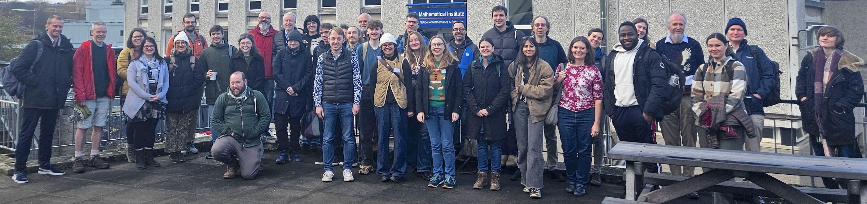
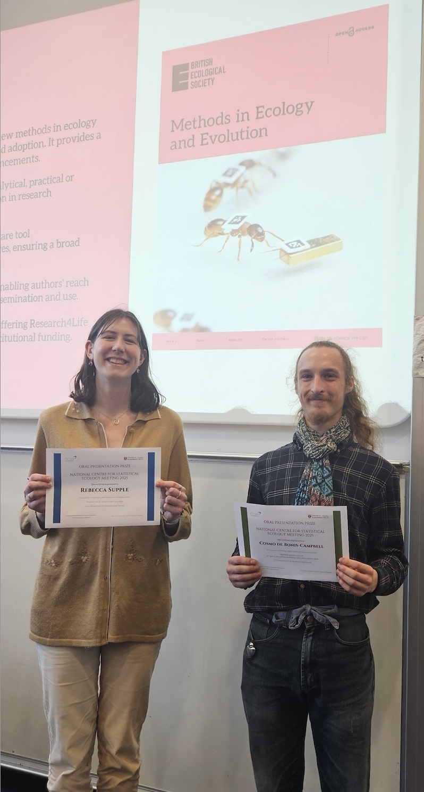
• From 17-19th December, St Andrews hosted the National Centre for Statistical Ecology Winter Meeting. Around 50 people attended, with St Andrews and CREEM naturally having a very strong presence. The first day was largely dedicated to a INLA and inlabru (statistical packages) workshop presented by Janine Illian (University of Glasgow, formerly St Andrews), with the remaining time given to individual presentations updating the network on current advancements and emerging areas. PhD students contributed nearly half of the talks and student prizes for best student talk went to St Andrews PhD student Rebecca Supple for ‘Practical use of causal graphs in ecology’ with highly commended mentions to Cosmo De Bonis-Campbell (Kent) and Amber Cowans (St Andrews). In a very positive end to the meeting a well-attended discussion about the future of the NCSE sparked lots of ideas for the committee to take forward.
Above: The NCSEW participants. Right: Rebecca Supple and
Cosmo De Bonis-Campbell with their prize certificates
• Ben Baer gave a presentation on mark scaling at CFE-CMStatistics2025 (Joint Conference on Computational and Financial Econometrics and Computational and Methodological Statistics) hosted by Birkbeck, University of London on 14th December, in a session on causal inference. The talk was highly interactive, with more than a dozen questions in the first 10 minutes. There seems to be significant academic interest in a foundation for mark scaling!
• James Mitchell attended the workshop Homogeneous Structures: Model Theory meets Universal Algebra from 14-19th December at the Oberwolfach Research Institute for Mathematics in Germany.
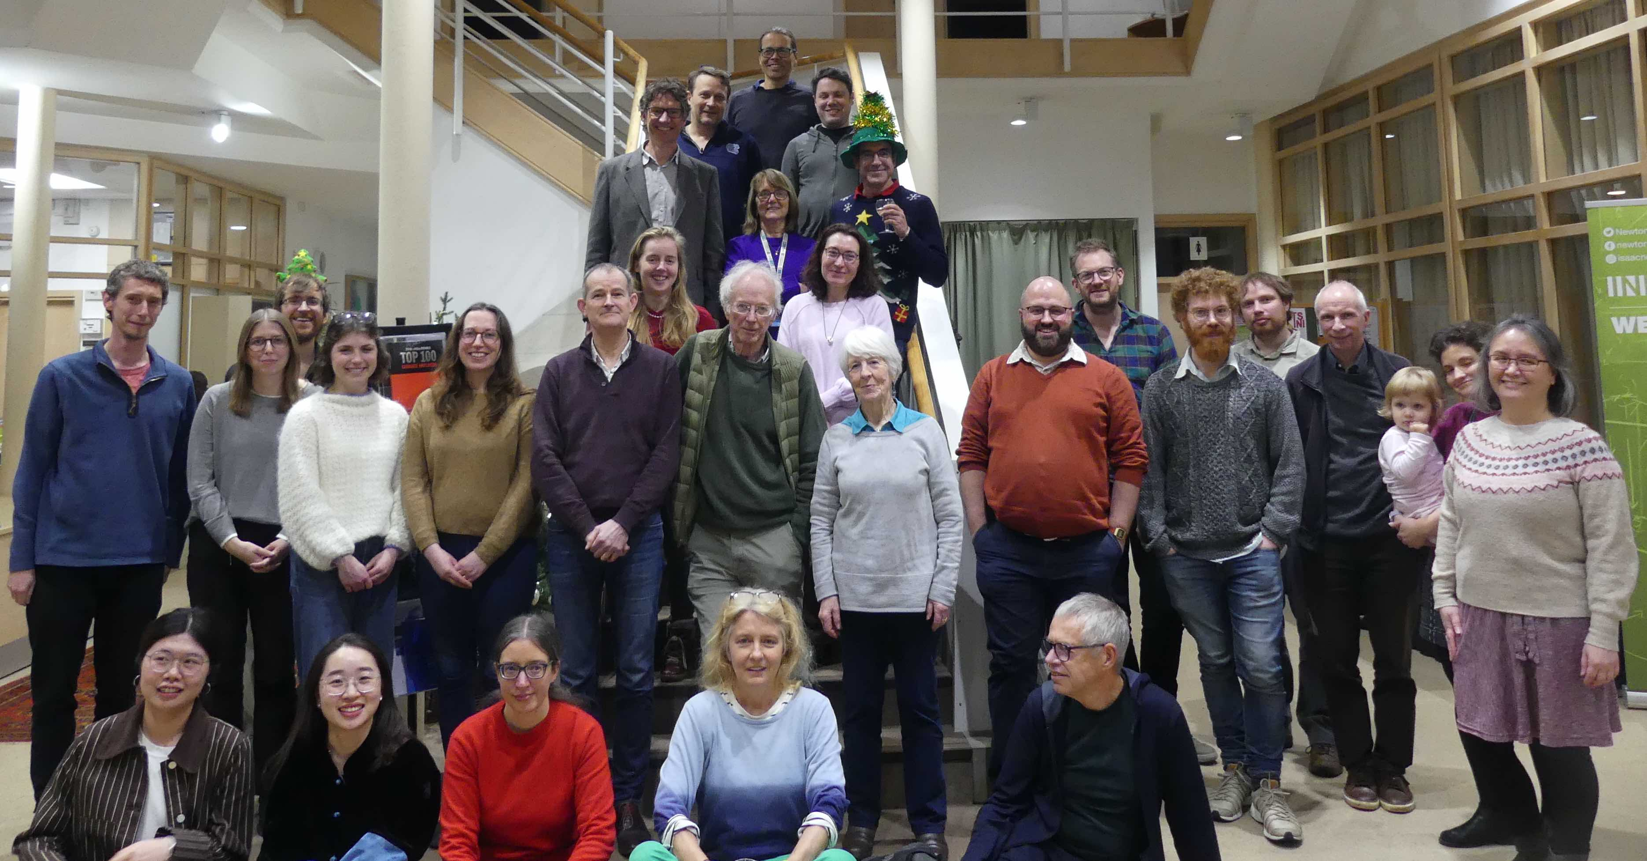
• From 18-20th December, Irene Kyza participated in the 19th Panhellenic Conference on Mathematical Analysis, which was held at SEMFE, NTU Athens, Greece (School of Applied Mathematical and Physical Sciences, National Technical University of Athens). Irene gave an invited talk at the session ‘Numerical Analysis’.
• From 8-20th December, Ben Swallow and Xiahui Li attended a follow-up programme at the Isaac Newton Institute, Cambridge on ‘Modelling and Inference for Pandemic Preparedness’. Work continued from nine research groups on aspects of statistical and mathematical modelling to support outbreak preparedness and response.
Pandemic Preparedness meeting at the INI

Other News
• Mark Chaplain’s magnum opus Mathematical Oncology, co-authored with Luigi Preziosi, was published by Springer on 1st January. This 857 page tome presents an overview of mathematical models developed to examine the stages of cancer growth and development. This hardcover book is essential reading for all mathematicians and can be yours for a mere £199.99, so order your copy now! See https://link.springer.com/book/10.1007/978-0-387-68564-9 - about-this-book
• Jeff Hicks and Laurent Côté (University of Bonn) were awarded a Global St Andrews and Bonn Doctoral Scholarship for a PhD student to work on ‘Generating categories in symplectic and algebraic geometry’.
• Jeff Hicks and Kai Hugtenburg were awarded funding under the LMS Celebrating New Appointments scheme to organize a three-day workshop ‘Symplectic geometry in St Andrews’ from 28-30th July 2026.
• Deborah Kent and Michael Friedman (Bonn) were awarded a University of St Andrews and University of Bonn Collaborative Research Grant for ‘On proofs and partnerships: How AI, big data, and proof assistants are transforming mathematical practices’. The Hausdorff Center for Mathematics in Bonn will host a related workshop on 16-17th June 2026, with a workshop in St Andrews expected in June 2027. Email Deborah dk89@st-andrews.ac.uk if you are interested in participating.

Future Events
• Our School Research Day will be held on Thursday 22nd January in Lecture Theatre C, starting at 9:30. Come along to hear what your colleagues are up to, from carcass-turbine radial distance density to the theory of mark scaling.

Next Issue
• The next edition of the School Newsletter will be circulated in February. Items may be sent to maths-news@st-andrews.ac.uk at any time but a reminder will be sent out a week before the deadline
.

